3. ReactJS-HOL

Create scorecalculatorapp with a Functional Component

Step 1: Create the React App
- Open VS Code
- Open a new folder for the project
- Open Terminal → Terminal → New Terminal
- Run:
npx create-react-app scorecalculatorapp

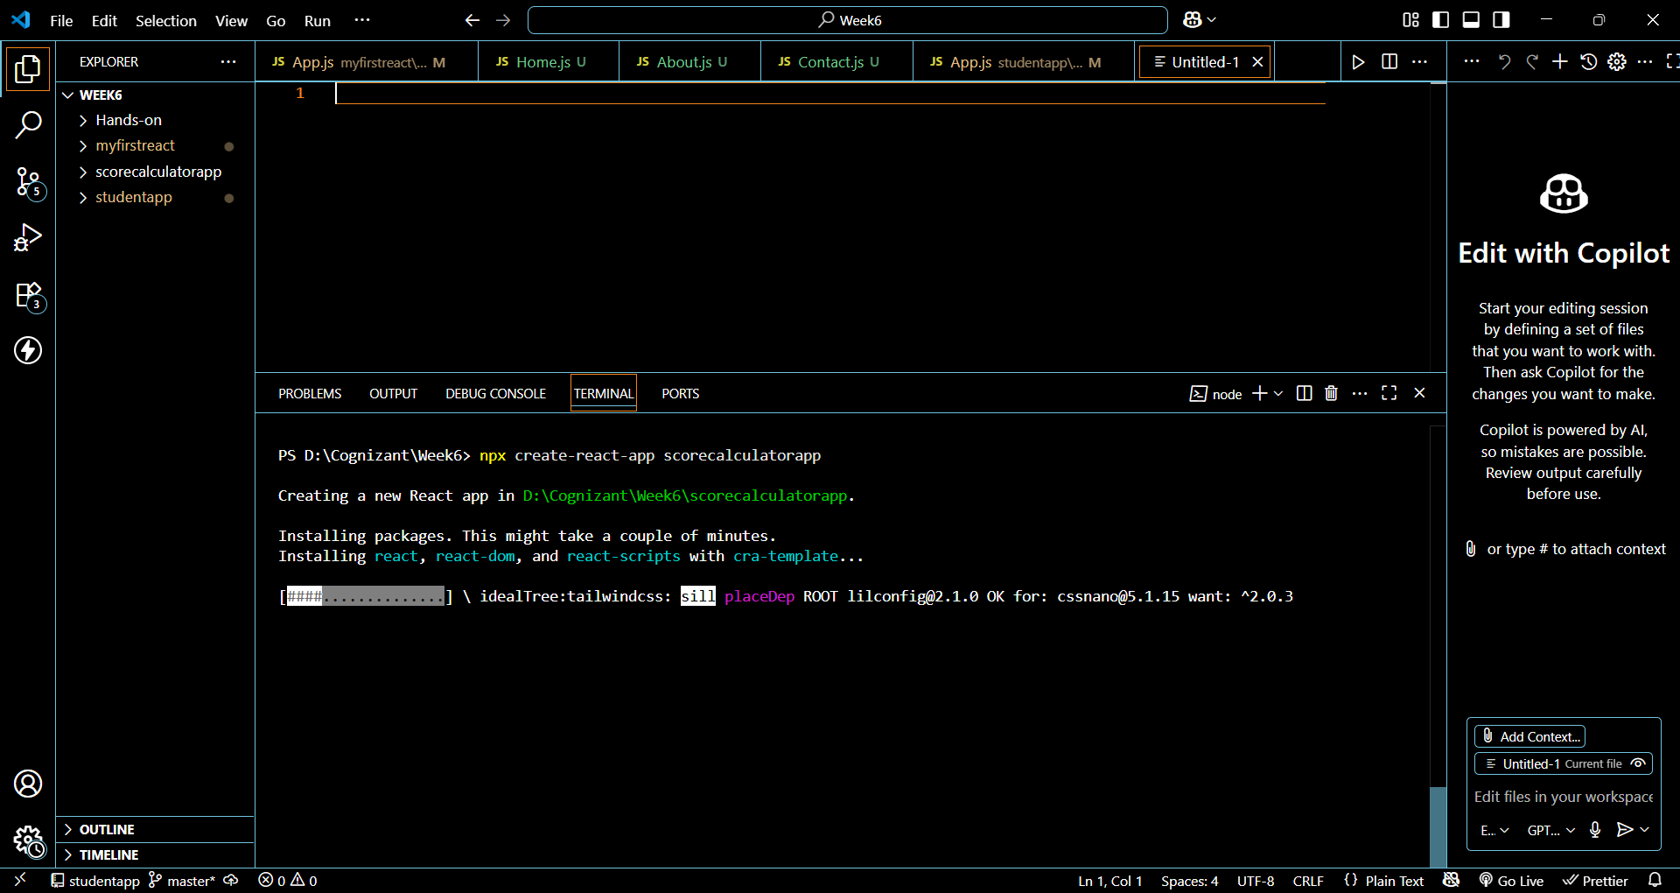

Step 2: Move Into the Project Directory
cd scorecalculatorapp

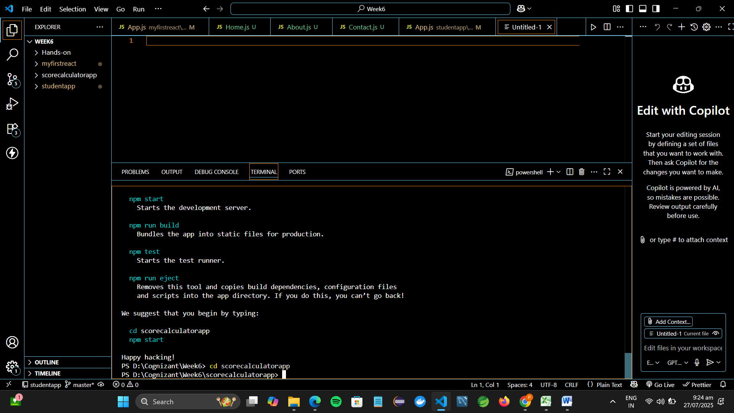

Step 3: Create Functional Component CalculateScore
- Inside src, create a folder named:
Components
- Inside Components, create a file:
CalculateScore.js

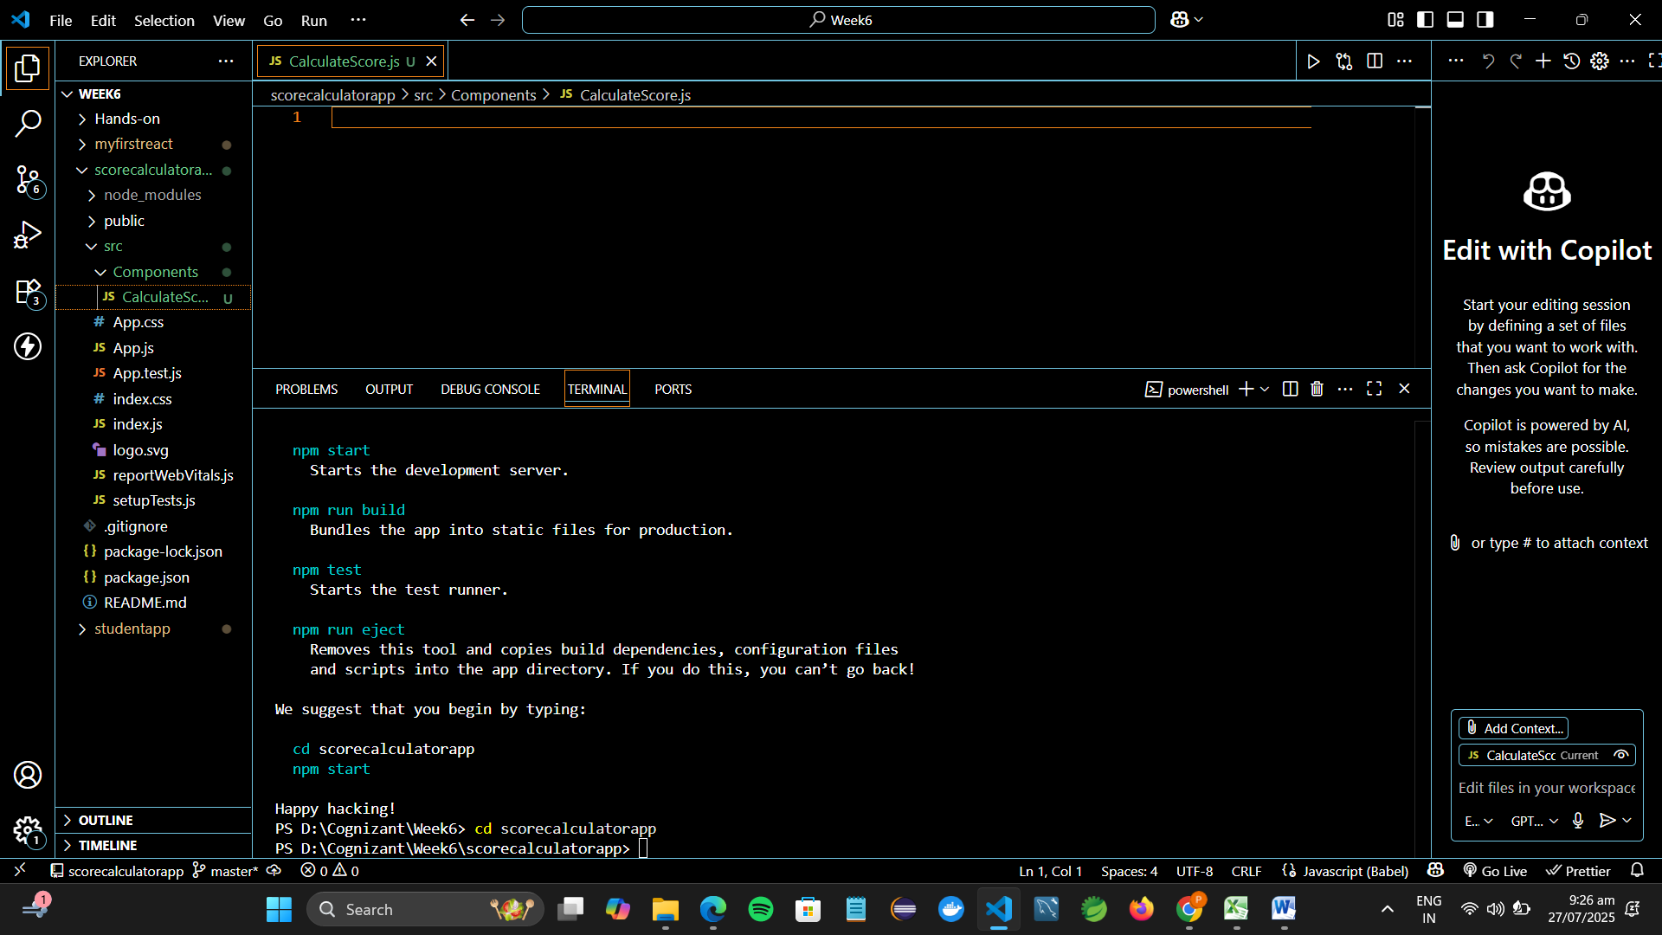
- Add the following code to CalculateScore.js:
import React from 'react';
import '../Stylesheets/mystyle.css';

function CalculateScore() {
const name = "Pooja";
const school = "SKCET";
const total = 450;
const goal = 500;
const average = (total / goal) * 100;

return (
<div className="score-container">
<h2>Student Score Calculator</h2>
<p><strong>Name:</strong> {name}</p>
<p><strong>School:</strong> {school}</p>
<p><strong>Total Marks:</strong> {total}</p>
<p><strong>Goal:</strong> {goal}</p>
<p><strong>Average Score:</strong> {average.toFixed(2)}%</p>
</div>
);
}

export default CalculateScore;

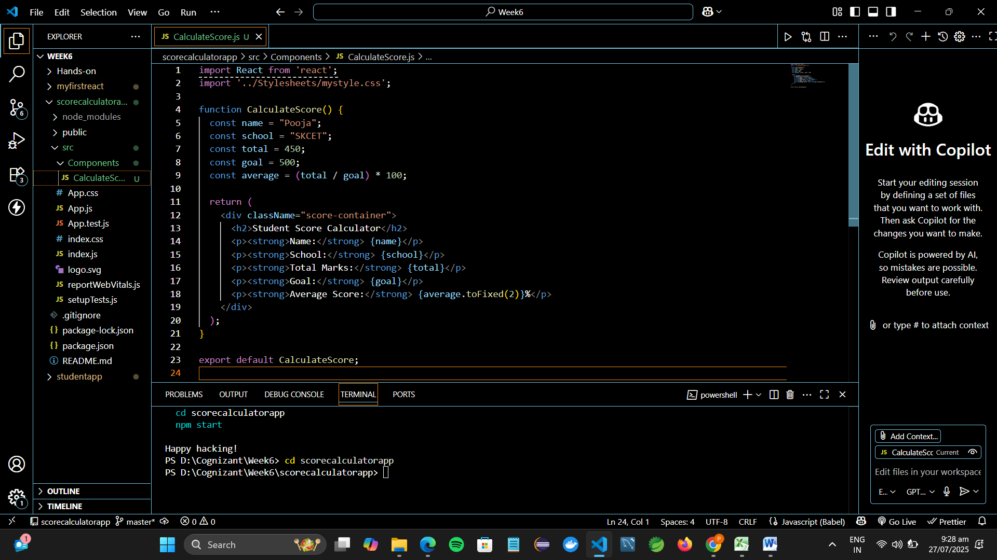

Step 4: Add Styling with mystyle.css
- Inside src, create a folder:
Stylesheets
- Inside Stylesheets, create a file:
mystyle.css

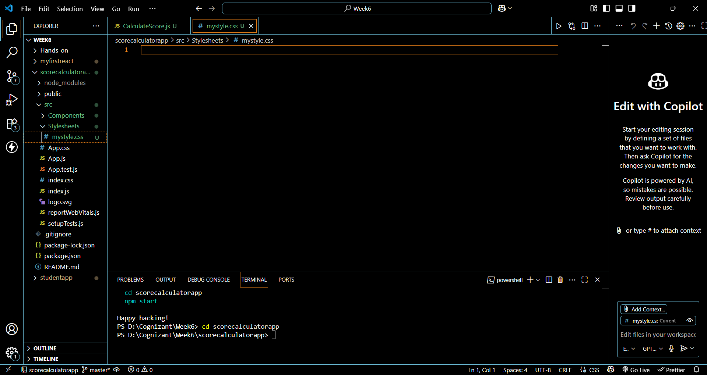
- Add some styles:
.score-container {
background-color: #f5f5f5;
border: 2px solid #4caf50;
padding: 20px;
width: 400px;
margin: 40px auto;
border-radius: 10px;
text-align: left;
font-family: 'Arial', sans-serif;
}

.score-container h2 {
color: #4caf50;
text-align: center;
}

.score-container p {
font-size: 16px;
margin: 8px 0;
}

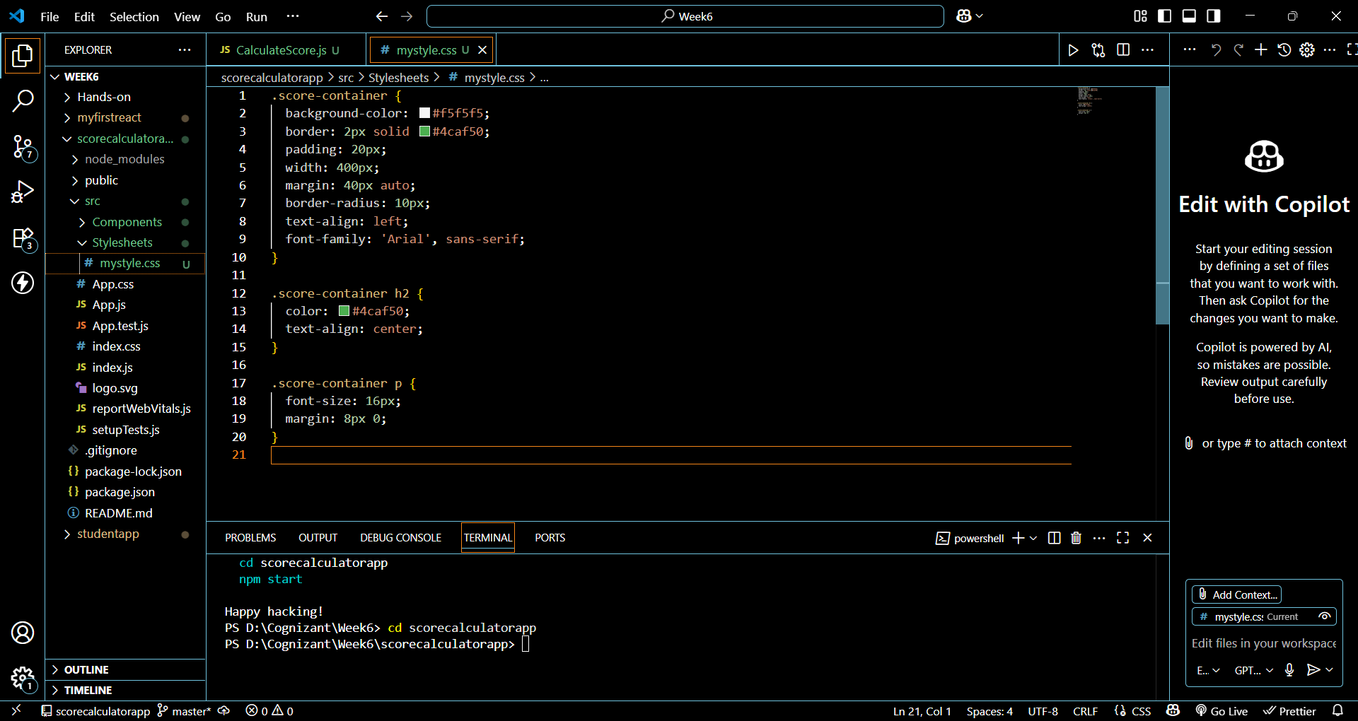

Step 5: Edit App.js to Render the Component
In src/App.js, replace everything with:
import React from 'react';
import CalculateScore from './Components/CalculateScore';

function App() {
return (
<div className="App">
<CalculateScore />
</div>
);
}

export default App;

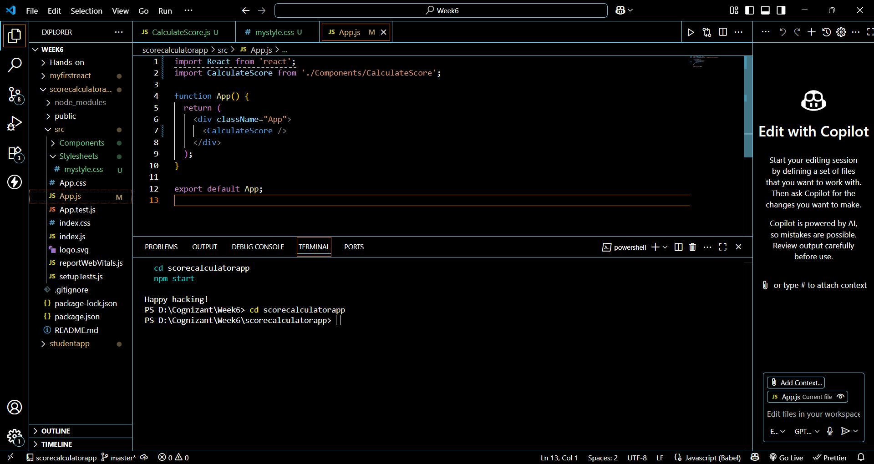

Step 6: Run the App
In terminal (inside scorecalculatorapp folder), run:
npm start

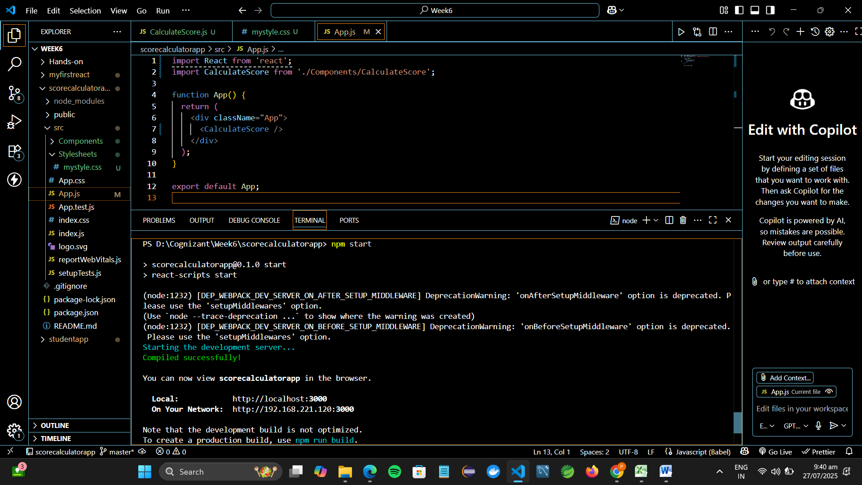

Step 7: View in Browser
Open a browser and visit:
http://localhost:3000
You should see a styled box showing:
- Student name
- School name
- Total marks
- Goal
- Calculated average in %

Result:
